**VSSHARE**

**QUICK START :**

1. **Create a new Canvas if there is no Canvas in your scene.**

To create a new one : 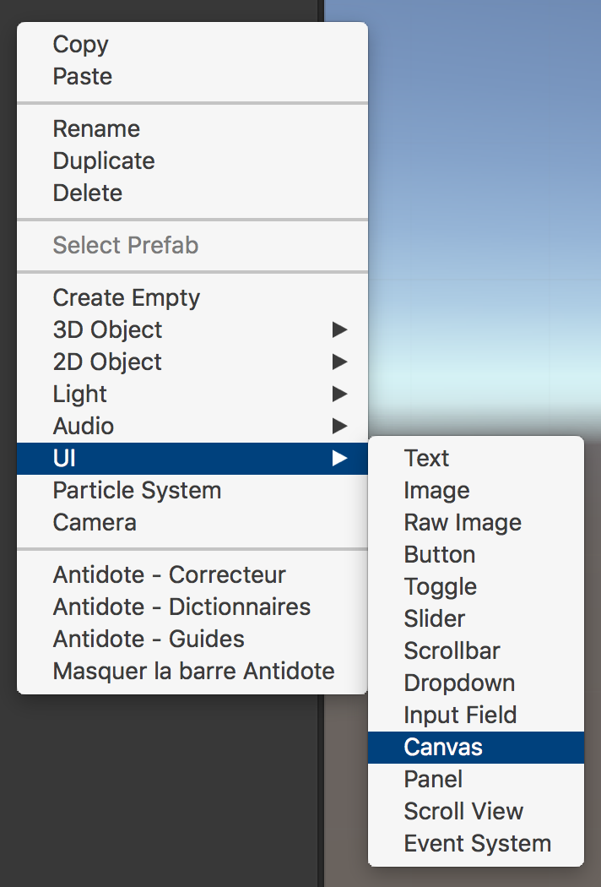

1. **Find the VSSHARE prefab :**

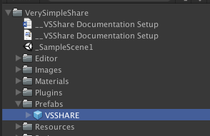

1. **Drag and drop the VSShare prefab in the scene as a child of the Canvas :**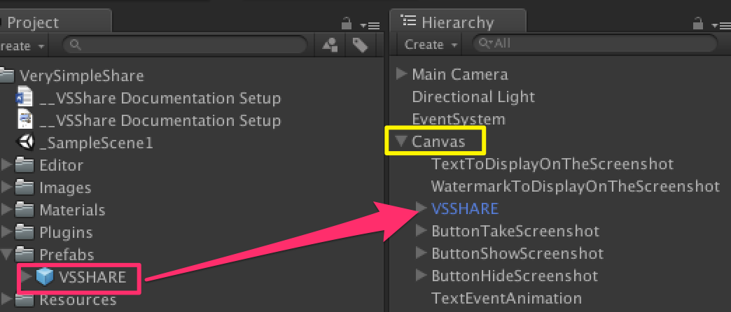

1. **Take the screenshot :**

Always import the sharing system at the top of your script to be able to call the methods :

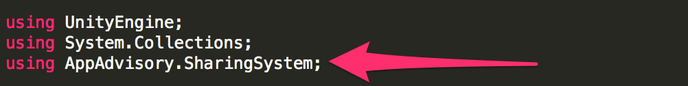

To take a screenshot, you have to call this method :

**../../../../../../../../../var/folders/3d/_68g_lwn0zb4d4rm9spylztm0000gn/T/com.skitch.skitch/DMDA5ED7CFD-D4D0-4CB9-BB62-6C64BBC0B76A/Assembly-CSharp_-_VerySimpleShare_Scripts_Exemple_BtnTakeScreenshot_c**

1. **Show the screenshot :**

You can show the screenshot only after you take one.

To show the screenshot in the VSSHARE UI Game Object, call this method :

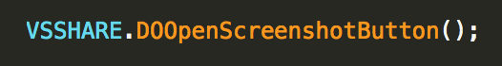

The VSSHARE **button** will appear on the screen.

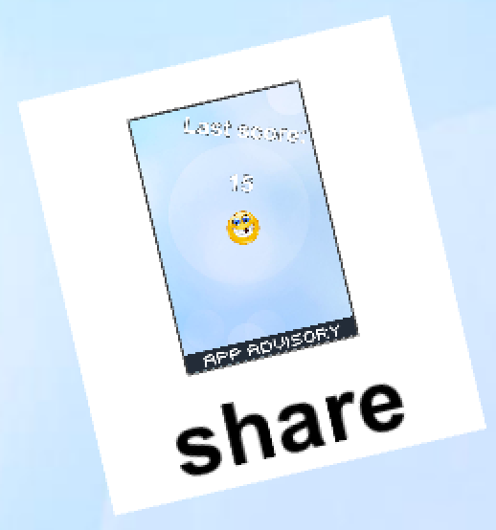

(image from the demo scene)

You can close (= hide) the screenshot button (at this state only) by calling :

../../../../../../../../../var/folders/3d/_68g_lwn0zb4d4rm9spylztm0000gn/T/com.skitch.skitch/DMDA373E035-7012-4264-8F98-8FEC8280995B/Assembly-CSharp_-_VerySimpleShare_Scripts_Exemple_BtnHideScreenshotIcon_c

1. **Open the screenshot sharing window:**

Just click/touch the VSSHARE button (view in 5) section).

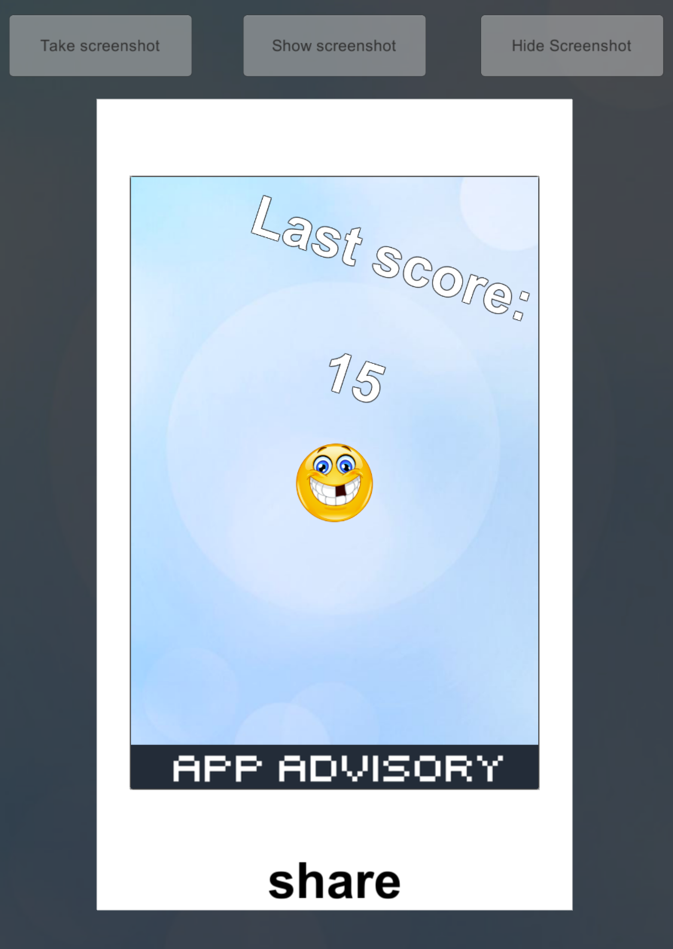

(image from the demo scene)

You can do it from code with this method :

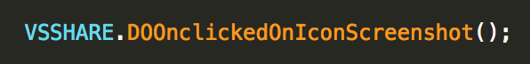

1. **Share or close the screenshot sharing window:**

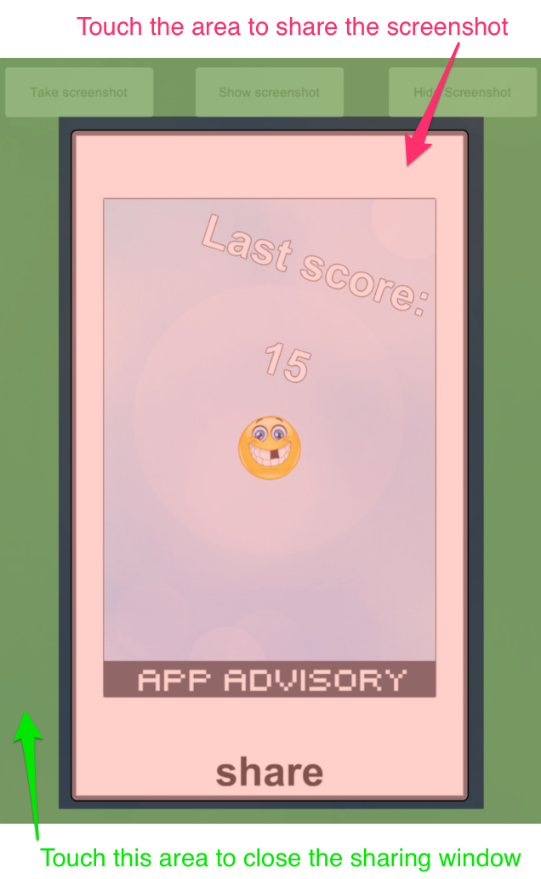

(image from the demo scene)

To close this windows from code :

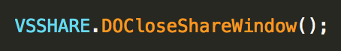

To share the screenshot from code :



**DELEGATES**

You can subscribe to some delegates to have more controls.

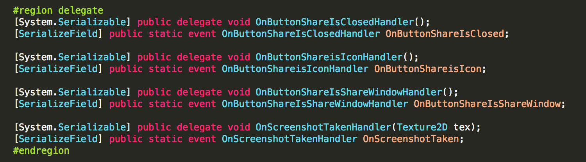

**Delegate who is called when a screenshot is taked :**



Exemple of use :

BtnTakeScreenshot.cs in the exemple scene.

Make the subscription :



Receive the event :

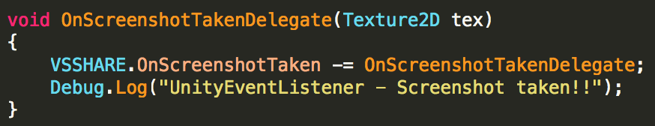

The delegate return the Texture2D (= the screenshot).

**Delegate who is called when the VSSHARE if in the icon state :**



Make the subscription :

../../../../../../../../../var/folders/3d/_68g_lwn0zb4d4rm9spylztm0000gn/T/com.skitch.skitch/DMDD221CD0E-2481-45F5-AD6F-A54FCE1C7DFE/Assembly-CSharp_-_VerySimpleShare_Scripts_Exemple_BtnTakeScreenshot_c

Receive the event :

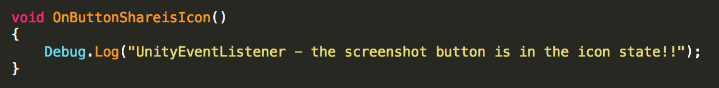

**Delegate who is called when the VSSHARE if in the full screen sharing window state :**

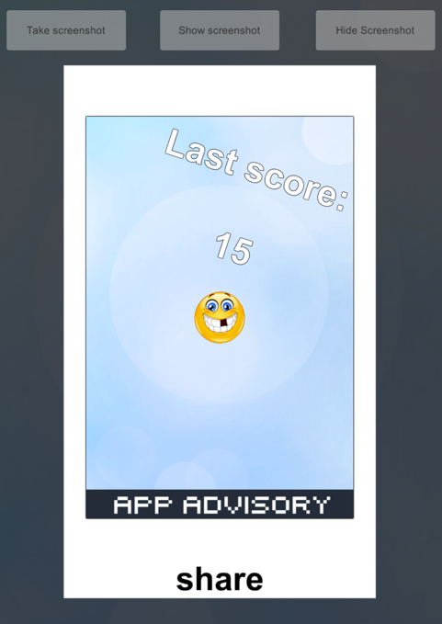



Make the subscription :



Receive the event :

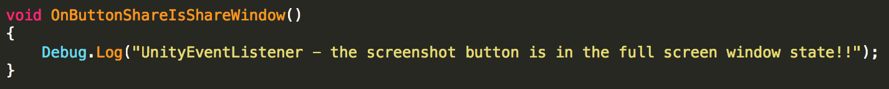

**Delegate who is called when the VSSHARE is closed:**



Make the subscription :

../../../../../../../../../var/folders/3d/_68g_lwn0zb4d4rm9spylztm0000gn/T/com.skitch.skitch/DMD5295060D-9F85-45B7-AED7-357B67E8DA7C/Assembly-CSharp_-_VerySimpleShare_Scripts_Exemple_BtnTakeScreenshot_

Receive the event :

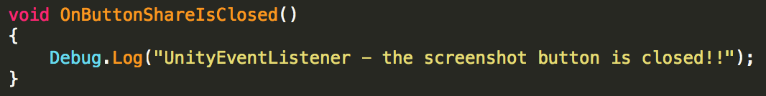

**Customization**

**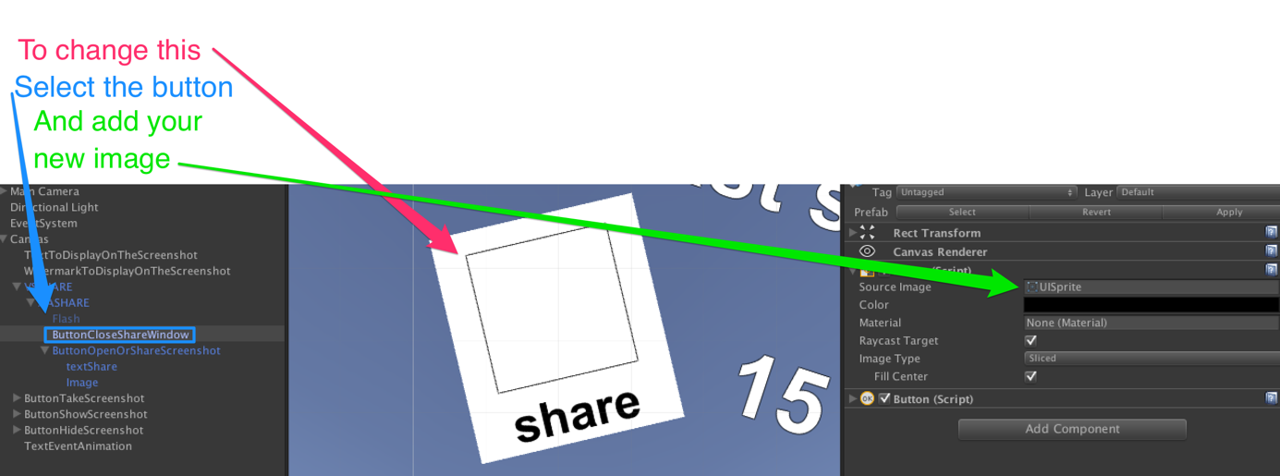**

**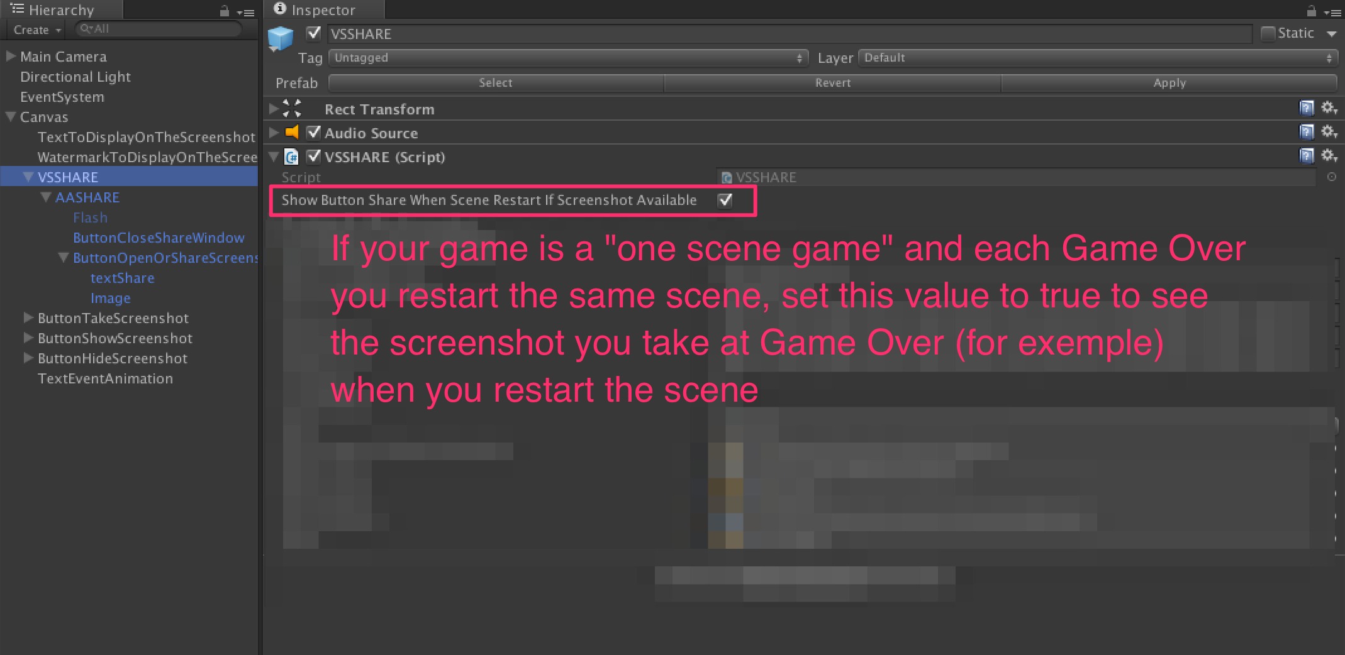**

**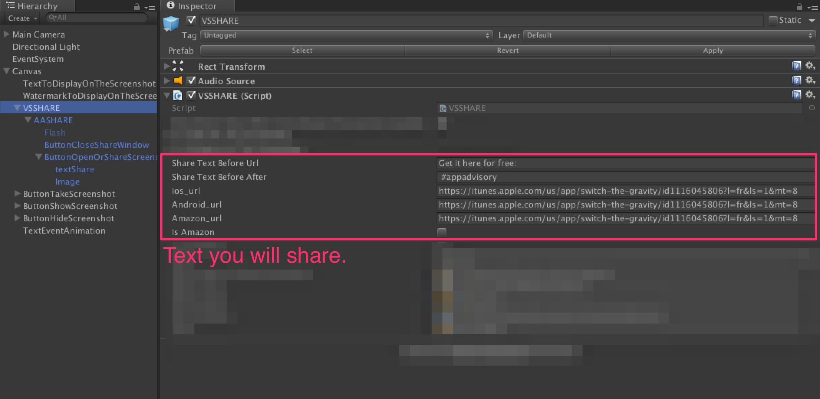**

**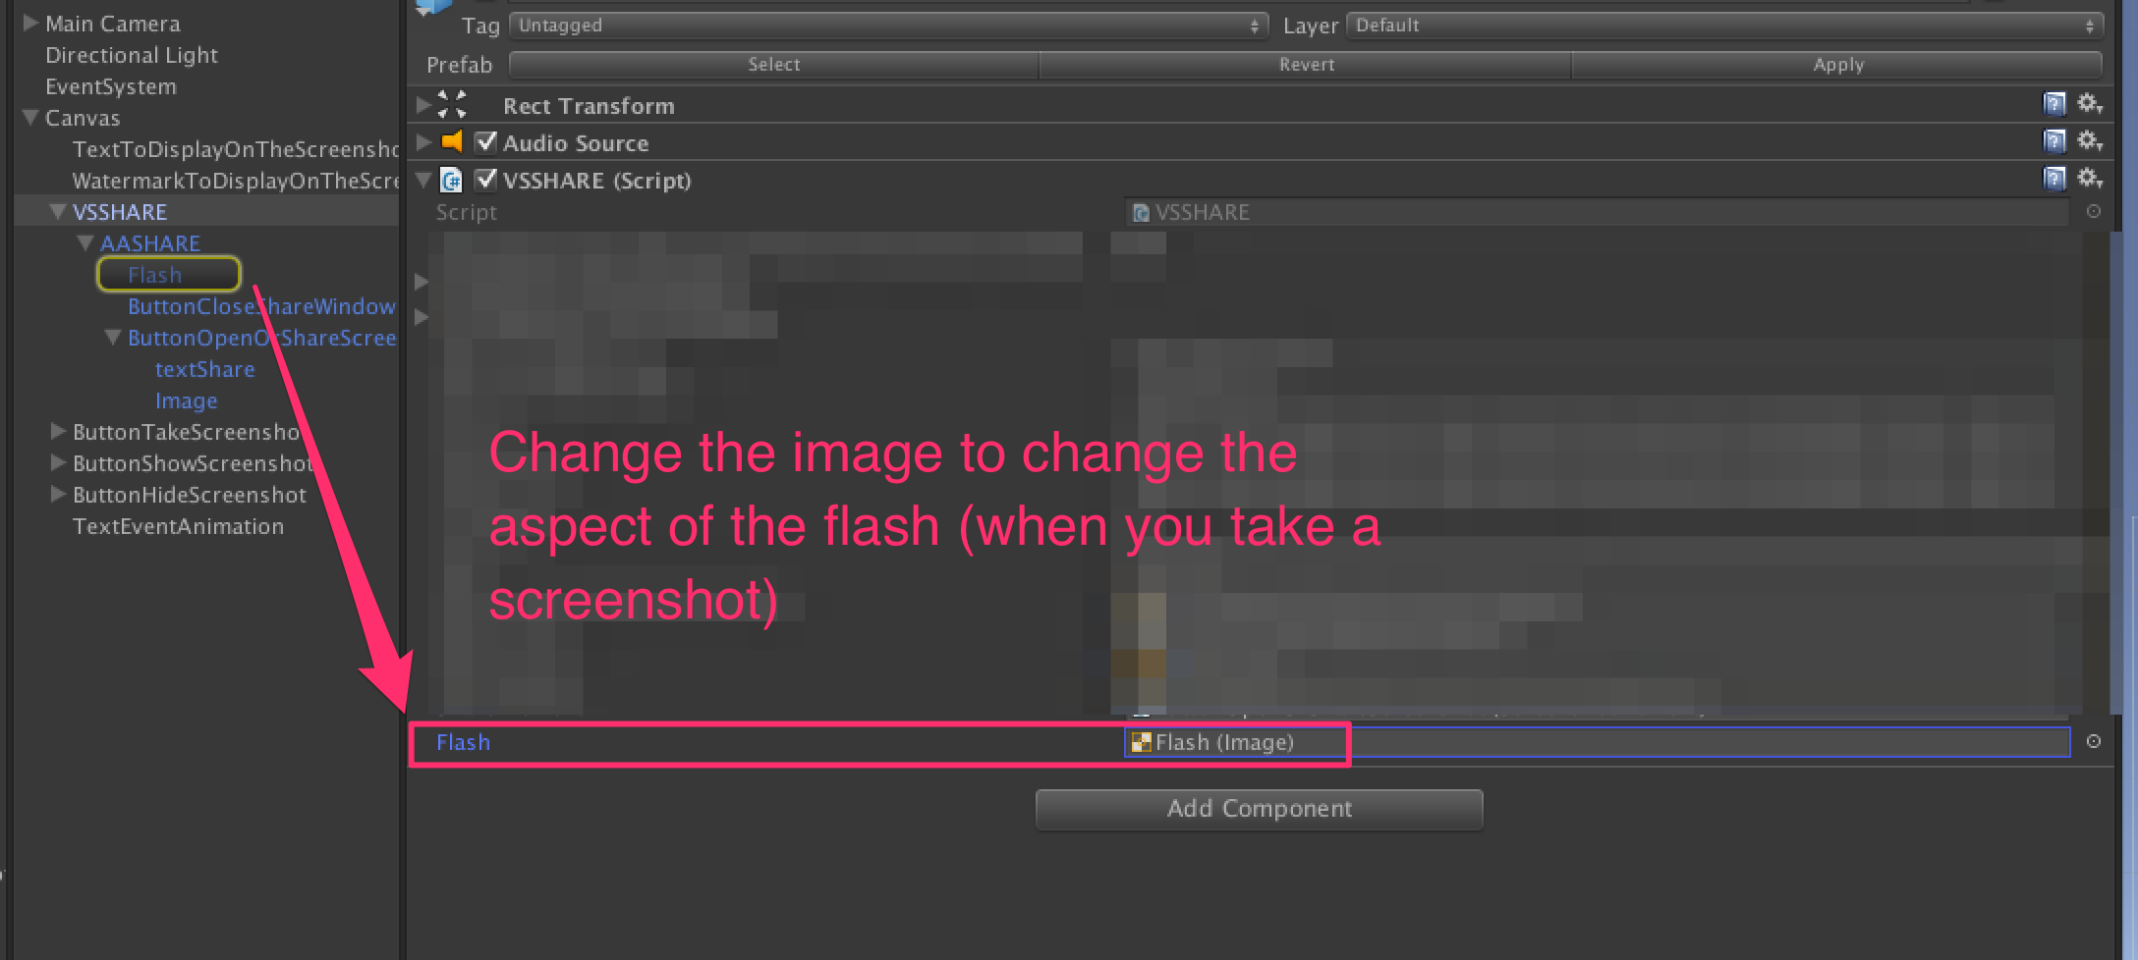**

**TIPS :**

* Add text, image (like watermark) etc to the screenshot (and only visible on the screenshot !) :

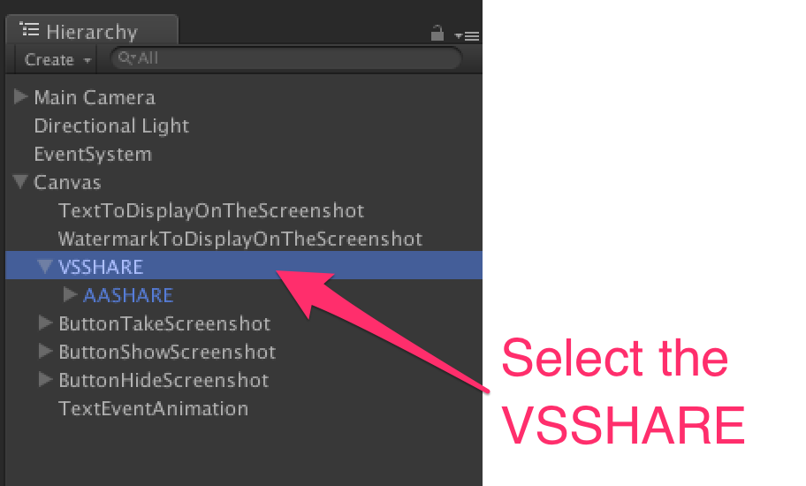

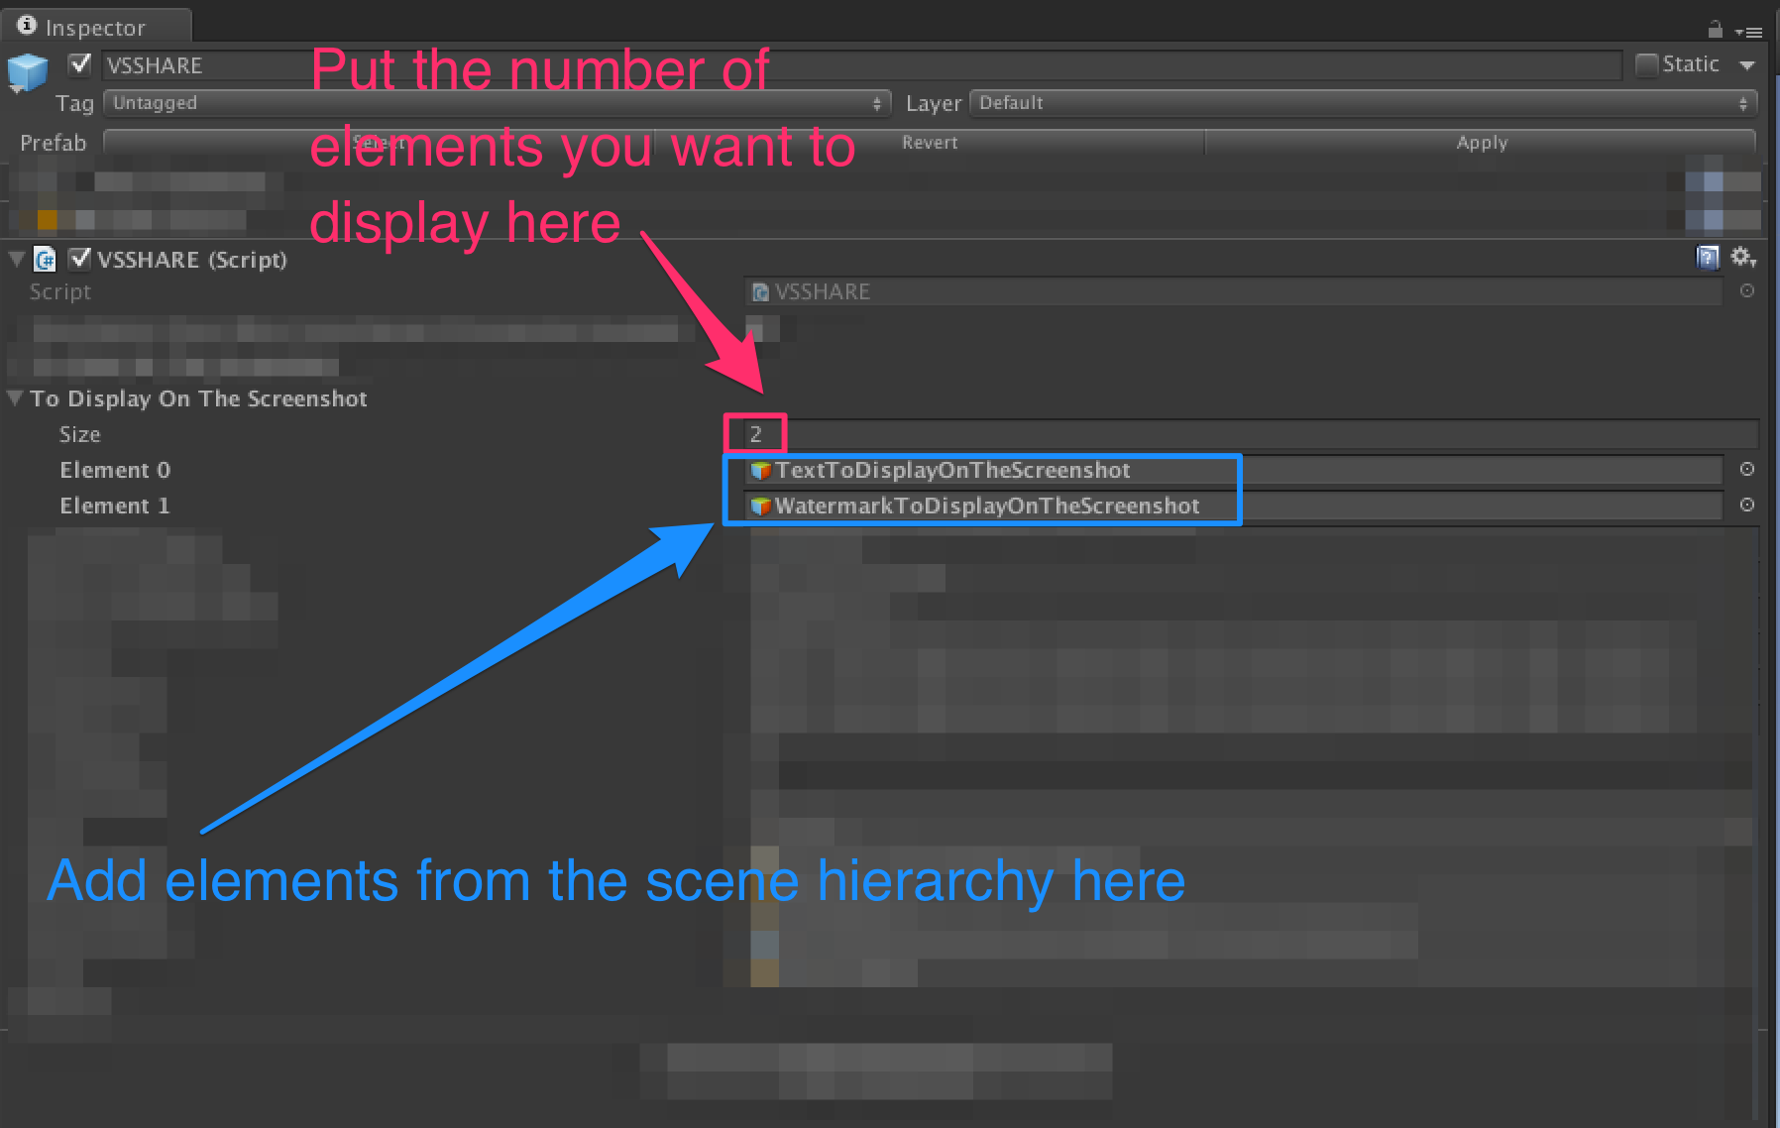

* Hide some scene elements in the screenshot :

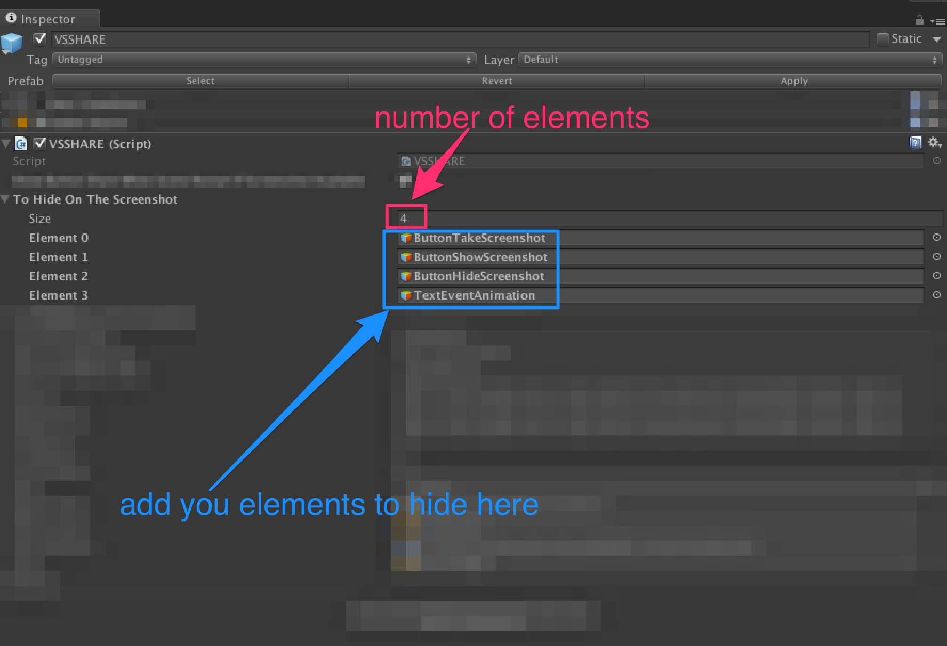

Thanks !

Our other assets : <http://u3d.as/9cs>

Inquiries : <https://appadvisory.zendesk.com/>